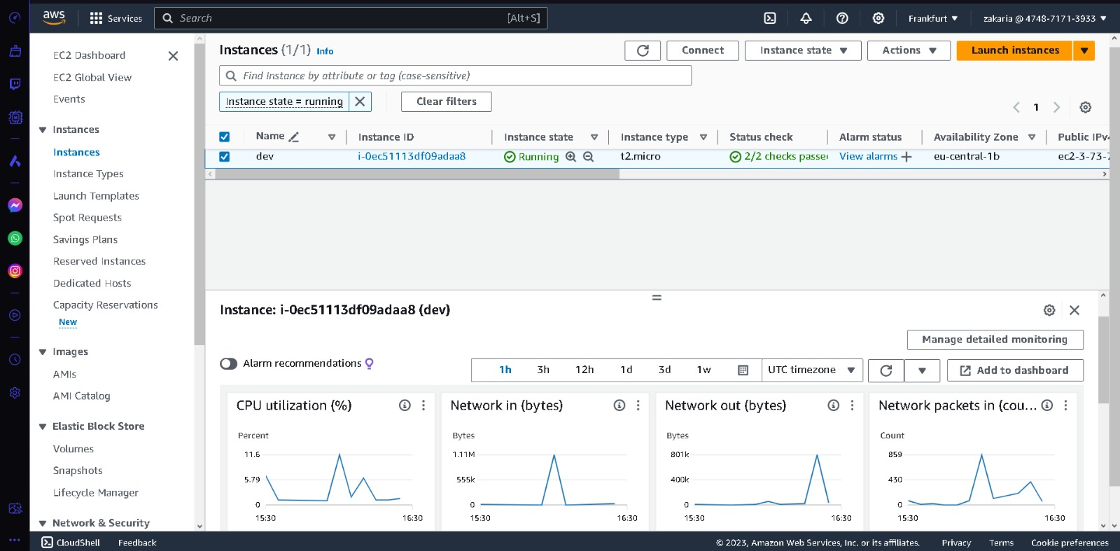

This is aws's management console and we use it to provision one ec2 instance where we are gonna deploy our java app.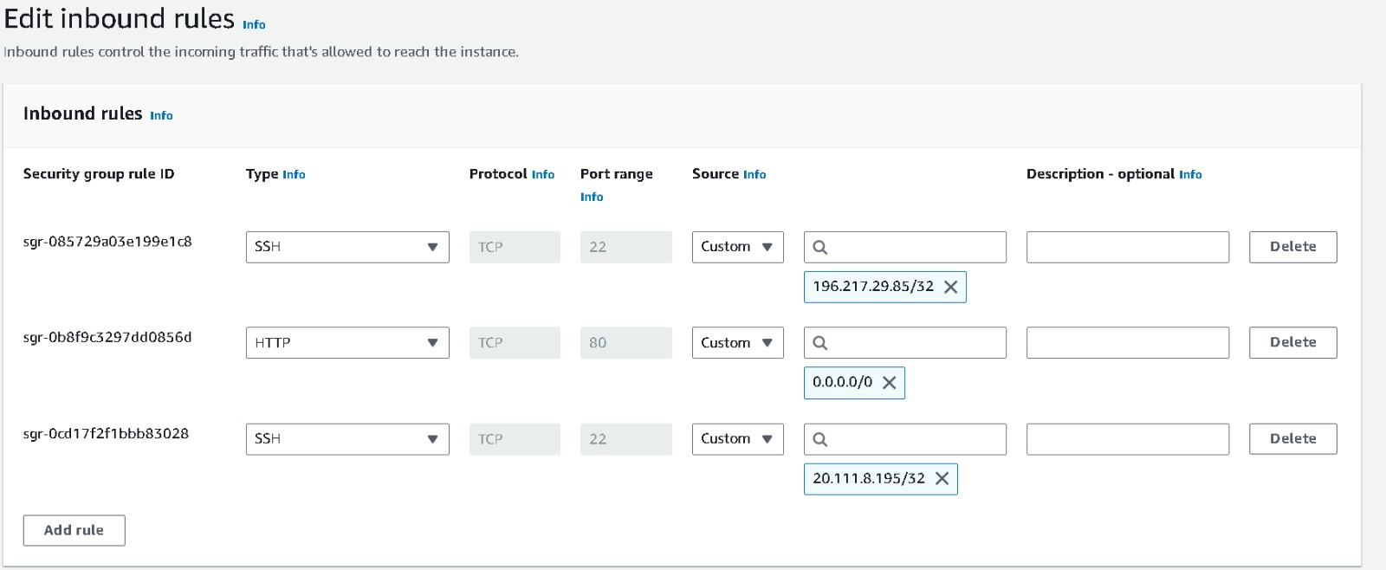

This is security group to allow users from the internet to access our app

we open the port 80 (http) and also port 22 (ssh) so that we can ssh to our instance and do the necessary to run our application.

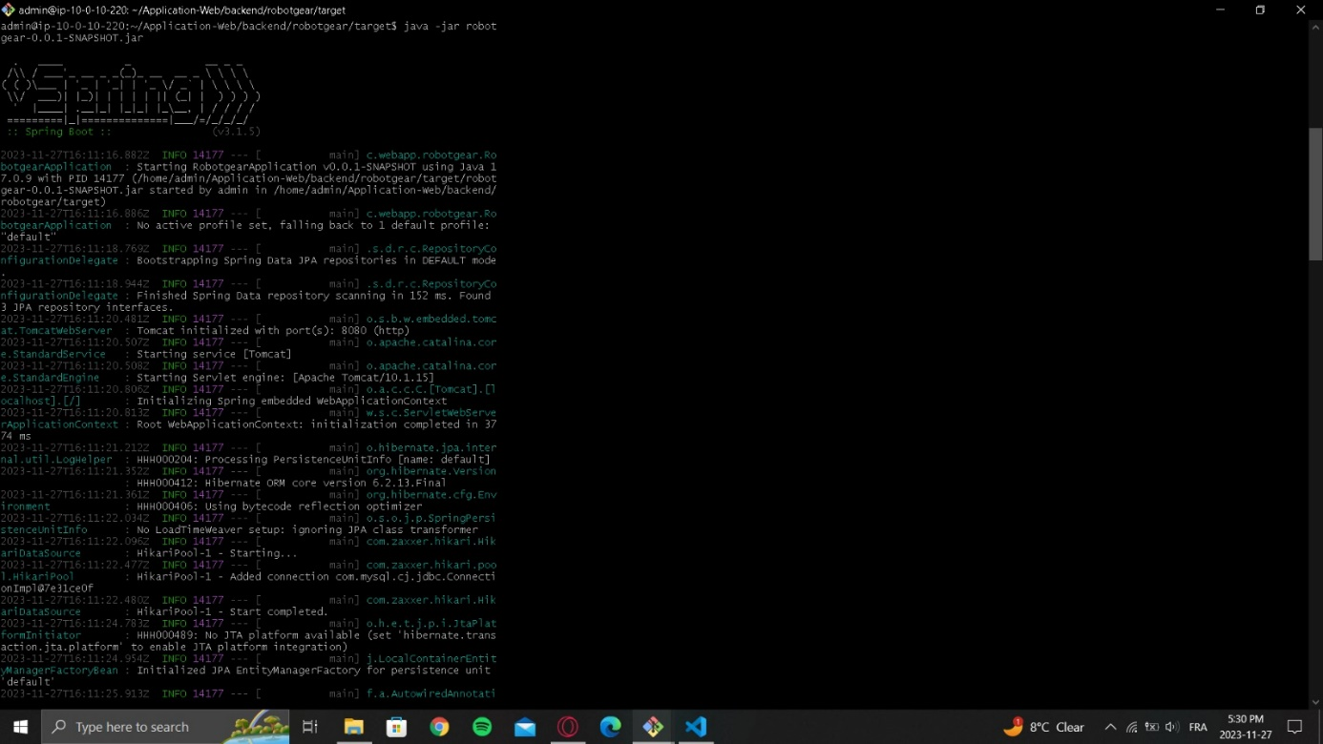

We run our app in the ec2 instance using the following command java -jar robotgear.jar

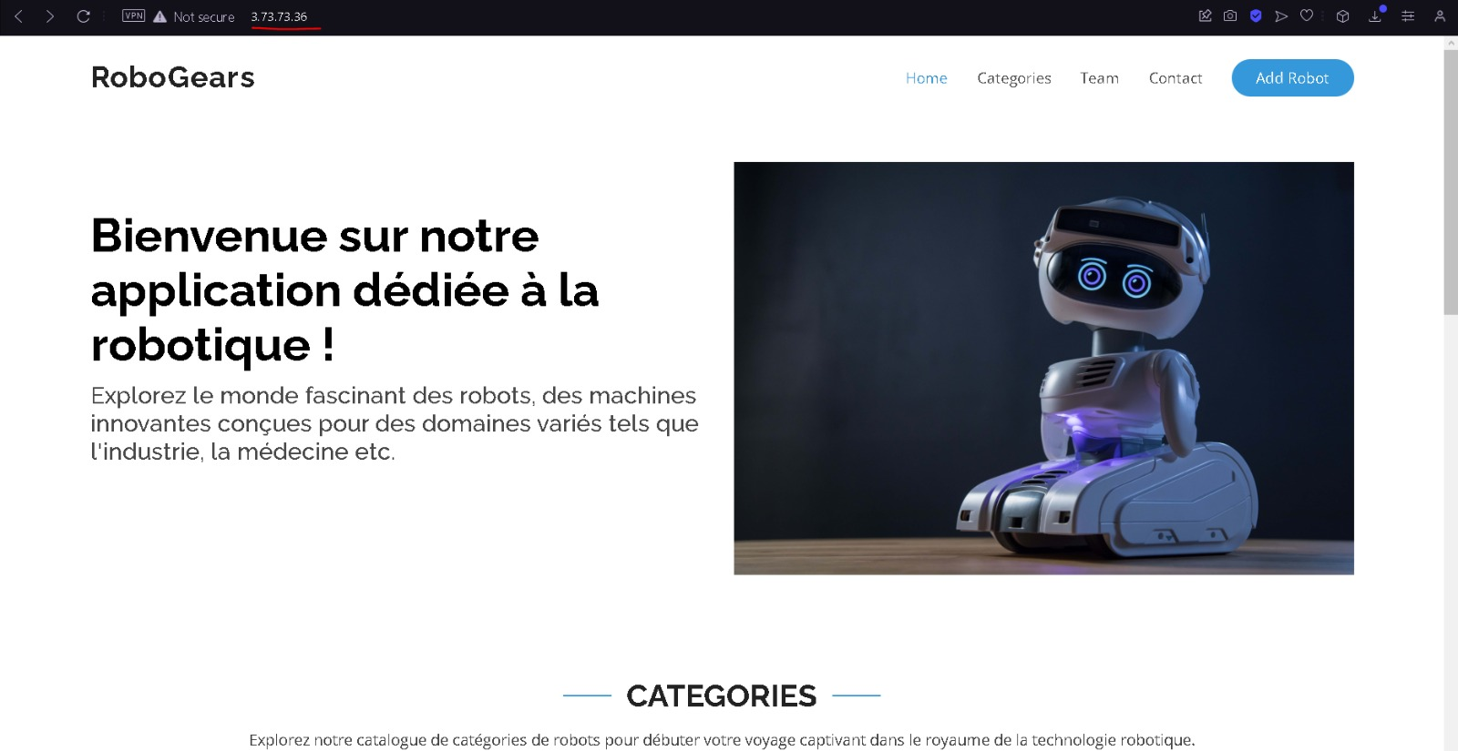

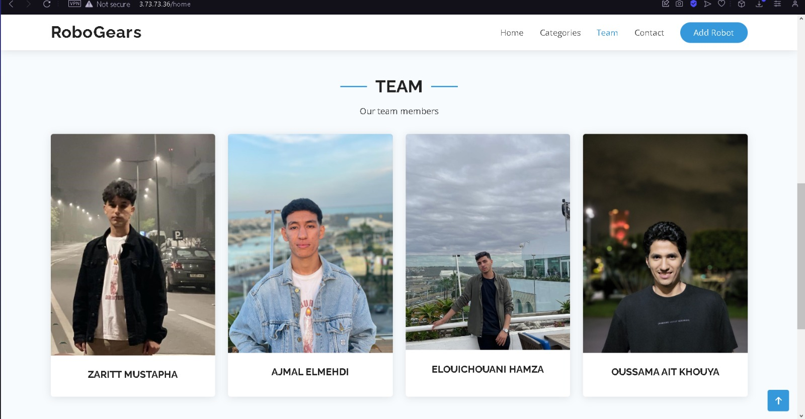

We successfully run the app in the cloud as the following picture shows.